Project Design Phase-II

Data Flow Diagram & User Stories

|  |  |
| --- | --- |
| Date | 03 October 2022 |
| Team ID | PNT2022TMID17703 |
| Project Name | Project - A Novel Method for Handwritten Digit Recognition System |
| Maximum Marks | 4 Marks |

Data Flow Diagrams:

USER

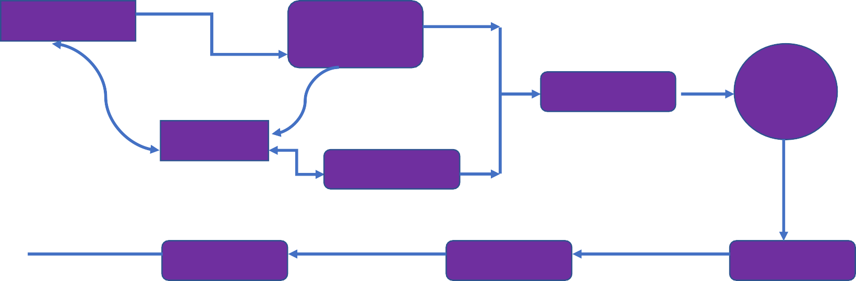

1. **Open Application**
2. **Input**

Handwritten Image

4.Apply CNN LAYER

Framing Digits

CNN LAYER

8.Display Result

Application

MNIST Dataset

3.Framing with

Bounding Box

5. Training

Output

7. Final Result

Testing Data

6. Testing

Training Data

User Stories

|  |  |  |  |  |  |  |
| --- | --- | --- | --- | --- | --- | --- |
| **User Type** | **Functional Requirement (Epic)** | **User Story Number** | **User Story / Task** | **Acceptance criteria** | **Priority** | **Release** |
| Customer (Mobile user) | Home page | USN-1 | As a user, I can view the guide and awareness to use this application. | I can view the awareness to use this application and its limitations. | Low | Sprint-1 |
|  |  | USN-2 | As a user, I’m allowed to view the  guided video to use the interface of this  application. | I can gain knowledge to use this application by a practical method. | Low | Sprint-1 |
|  |  | USN-3 | As a user, I can read the instructions to use this application. | I can read instructions also to use it in a user- friendly method. | Low | Sprint-2 |
|  | Recognize | USN-4 | As a user, In this prediction page I get to choose the image. | I can choose the image from our local system and predict the output. | Medium | Sprint-1 |
|  |  | USN-5 | As a user need to choose mentioned format image as per the guided | I can choose the image correct format | High | Sprint-1 |
|  | Predict | USN-6 | As a user, I’m Allowed to upload and  choose the image to be uploaded | I can upload and choose the image from the  system storage and also in any virtual storage. | Medium | Sprint-3 |
|  |  | USN-7 | As a user, I will train and test the input  to get the maximum accuracy of output. | I can able to train and test the application until it  gets maximum accuracy of the result. | High | Sprint-4 |
|  |  | USN-8 | As a user, I can access the MNIST data  set | I can access the MNIST data set to produce the  accurate result. | Medium | Sprint-3 |
| Customer  (Web user) | Home | USN-9 | As a user, I can view the guide to use  the web app. | I can view the awareness of this application and  its limitations. | Low | Sprint-1 |
|  | Recognize | USN-10 | As a user, I can use the web application  virtually anywhere. | I can use the application portably anywhere. | High | Sprint-1 |
|  |  | USN-11 | As it is an open source, can use it cost  freely. | I can use it without any payment to be paid for it  to access. | Medium | Sprint-2 |
|  |  | USN-12 | As it is a web application, it is  installation free | I can use it without the installation of the  application or any software. | Medium | Sprint-4 |
|  | Predict | USN-13 | As a user, I’m Allowed to upload and  choose the image to be uploaded | I can upload and choose the image from the  system storage and also in any virtual storage. | Medium | Sprint-3 |